**Results**

**Case 1**: Vertices forming Regular Polygon where all vertices are part of Convex Hull with G at the geometric center.

Example depicted on page 2.

1. Weights are same for all the vertices.
2. All the three methods give same result.

**Case 2:** Vertices forming Polygon where all vertices are part of Convex Hull with G inside the convex hull.

Example depicted on pages 3 to 6.

1. Weights on the vertices are not same.
2. Weights are not directly proportional to distances although rough estimates suggest weights are more if the distance of vertex from G is less.
3. Weights are more related to area of a triangle formed by the vertex with its previous and next vertex in case of barycentric and its general form. There is no such direct observation for the case of mean value coordinates.
4. There is slight difference in the values calculated by the three methods.
5. Barycentric and Generalized Barycentric method give same results whereas values given by Generalized MV coordinates are different. But the difference is not much and can be regarded close to each other.

**Case 3:** Vertices forming Polygon where all vertices are part of Convex Hull with G at one of the vertices of convex hull.

Example depicted on page 7.

1. Both the generalized forms i.e. generalized MV coordinate and generalized Barycentric coordinate give correct result. They give weight as 100 at the vertex which coincides with G and weights at all other vertex are zero.
2. Barycentric coordinates have failed here to generate a finite value.

**Case 4:** Vertices forming Polygon where all vertices are part of Convex Hull with G outside the convex hull.

Example depicted on page 8.

1. The results shown by generalized mean value coordinates are not suitable for our cases (they are defined for G lying inside the polygon only). This is the only case (observed till now) where generalized MV coordinates are not satisfying our purpose.
2. Both forms of barycentric coordinates are showing results which can be made useful for our purpose.

**Case 5:** Vertices forming Polygon where all vertices are not part of Convex Hull with G inside the polygon.

Example depicted on page 9.

In real world scenarios, it is similar to below figure, where one foot rotates such that one heel is not the part of convex hull.

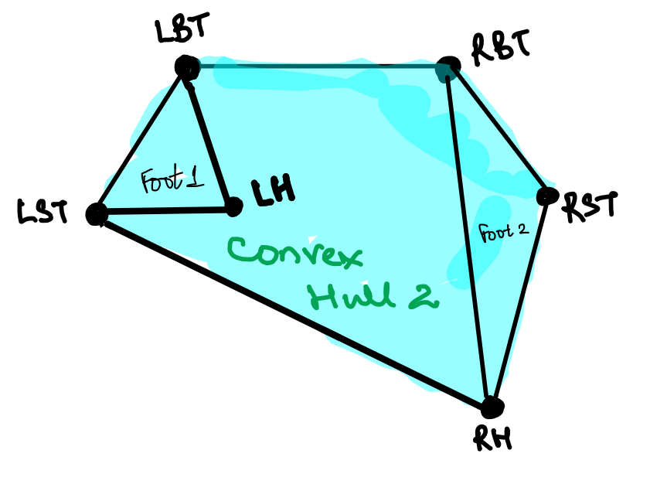

Figure 1: Left heel is not part of convex hull

1. Generalized mean value coordinates give results which are suitable for our case.
2. Both the form of barycentric coordinates are not useful for us.

**Case 5:** Vertices forming Polygon where all vertices are not part of Convex Hull with G coinciding with vertex which is inside convex hull.

Example depicted on page 10.

1. Generalized mean value coordinates give results which are suitable for our case. It gives weight as 100 at the vertex which is coinciding with G and 0 weight at other vertices.
2. Barycentric coordinates are not useful in this case as they failed to generate finite values.
3. Generalized Barycentric coordinates give results which are suitable for our case. It gives weight as 100 at the vertex which is coinciding with G and 0 weight at other vertices.

**Case 6:** Vertices forming Polygon where all vertices are not part of Convex Hull with G coinciding with a vertex which is forming convex hull.

Example depicted on page 11.

1. Generalized mean value coordinates give results which are suitable for our case. It gives weight as 100 at the vertex which is coinciding with G and 0 weight at other vertices.
2. Barycentric coordinates are not useful in this case as they failed to generate finite values.
3. Generalized Barycentric coordinates give results which are suitable for our case. It gives weight as 100 at the vertex which is coinciding with G and 0 weight at other vertices.

**Summary**

1. Generalized form are superior as they provide finite weights at the vertices.
2. Generalized Mean Value Coordinates are suitable for all the cases except when G is falling outside polygon boundaries.
3. Generalized Barycentric Coordinates are suitable for all the cases except when vertices are not forming convex hull.

Generalized Mean Value coordinates are defined when point G lies inside the polygon. If we reject the postures for which G lies outside the polygon, values of weights can give the required pressures at the vertices. But this is similar to checking whether G lies inside or outside convex hull.

If Generalized Barycentric coordinates are used, it fails for case shown in figure 1.